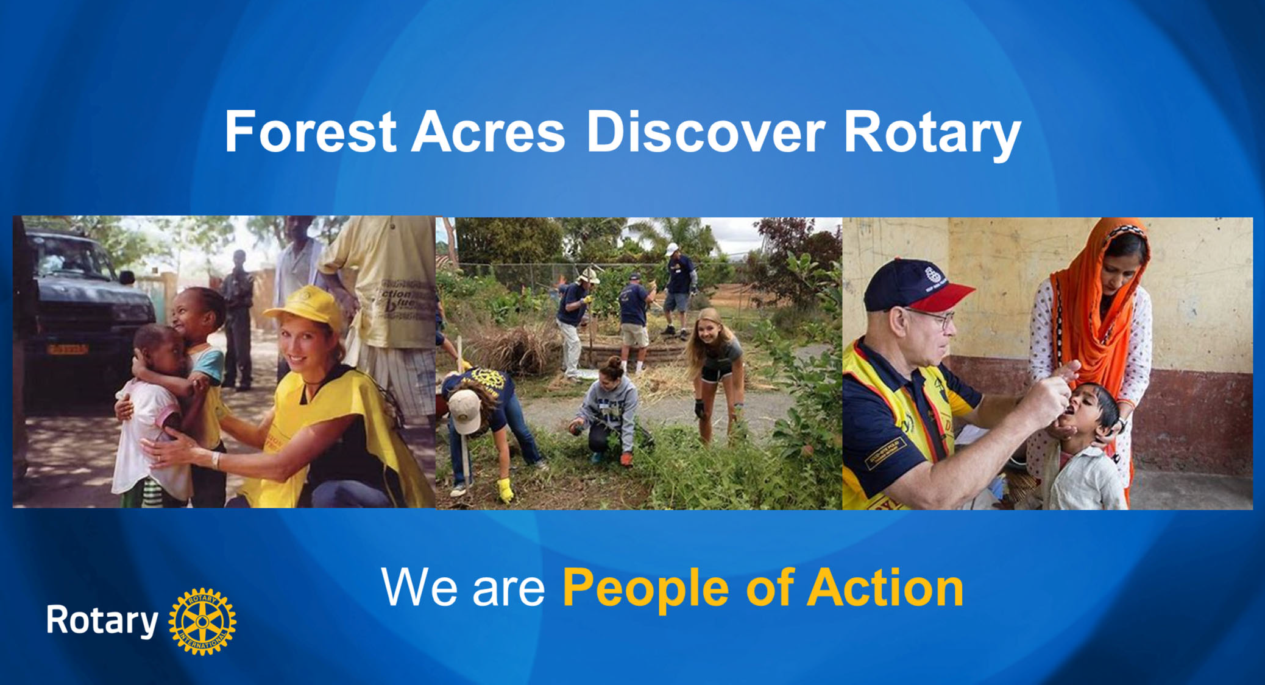

Welcome to Discover Rotary. Let’s begin by having everyone do a brief 30 second introduction to include name, vocation and for club members what attracted you to Rotary and what’s kept you coming back and for our potential members, what sparked your interest in Rotary. I am Sandy Olson of the Rotary Club of Forest Acres. My encore career includes teaching life‐long learning classes, mentoring and training Rotarians on intentional membership growth strategies. I joined Rotary for friends and fellowship and that kept me coming back for 19 years.

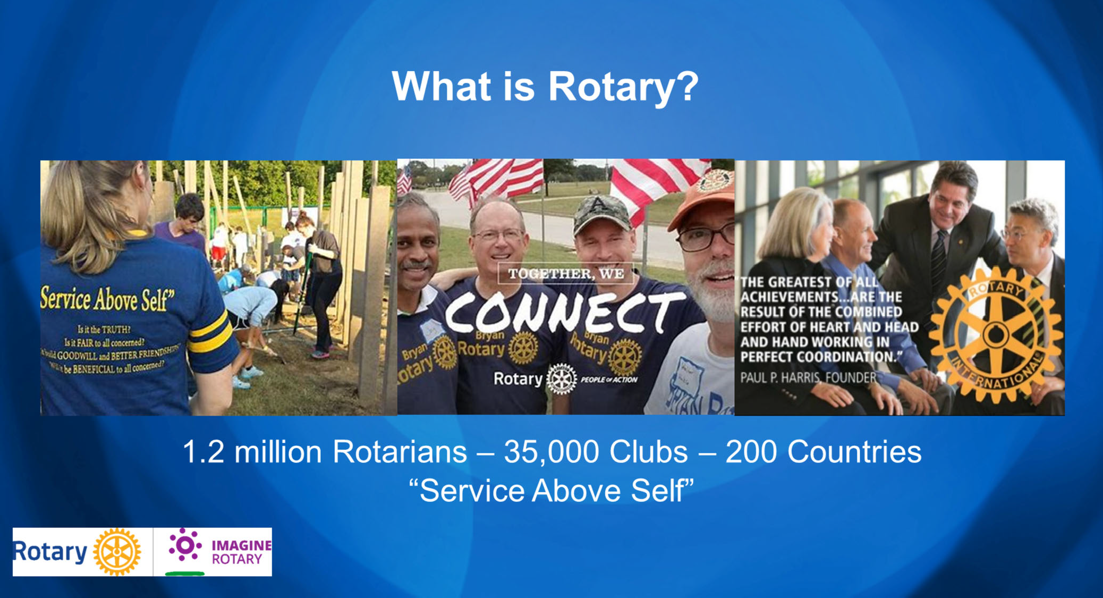

Rotary is a membership organization that does service. We are a global network of business and professional leaders. We do humanitarian service projects and encourage high ethical standards. We strive for goodwill and peace in the world. There are 1.2 million of us in 35,000 clubs in over 200 countries around the world. Our motto is Service Above Self.

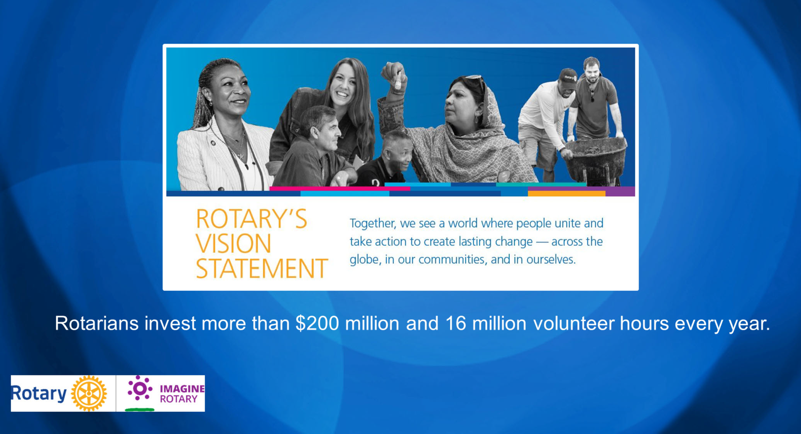

Rotarians are people of action because we are guided by a strong vision. Together, we see a world where people unite and take action to create lasting change – across the globe, in our communities, and in ourselves. Each year, Rotarians invest more than $200 million and 16 million volunteer hours to promote peace, fight disease, provide clean water, save mothers and children, support education and grow local economies.

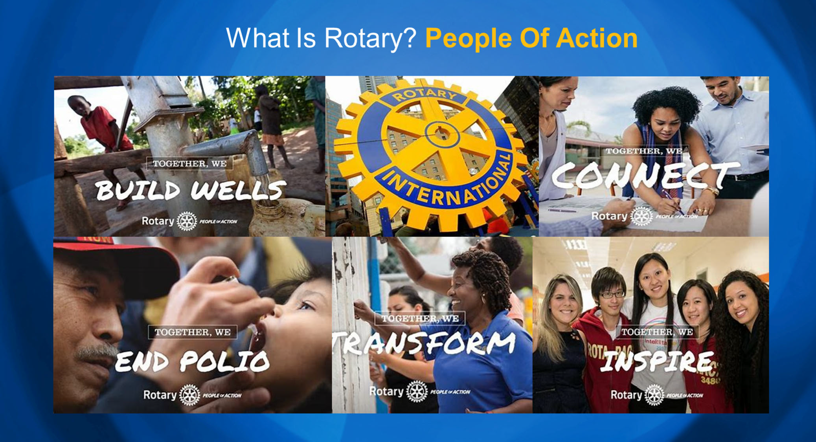

To answer the question what is Rotary… We are the largest most financially sound membership organization whose logo is recognized in more countries than any other in the world. Every minute of every day we feed, we house, we vaccinate, educate, advocate, comfort and provide services. This is Rotary!

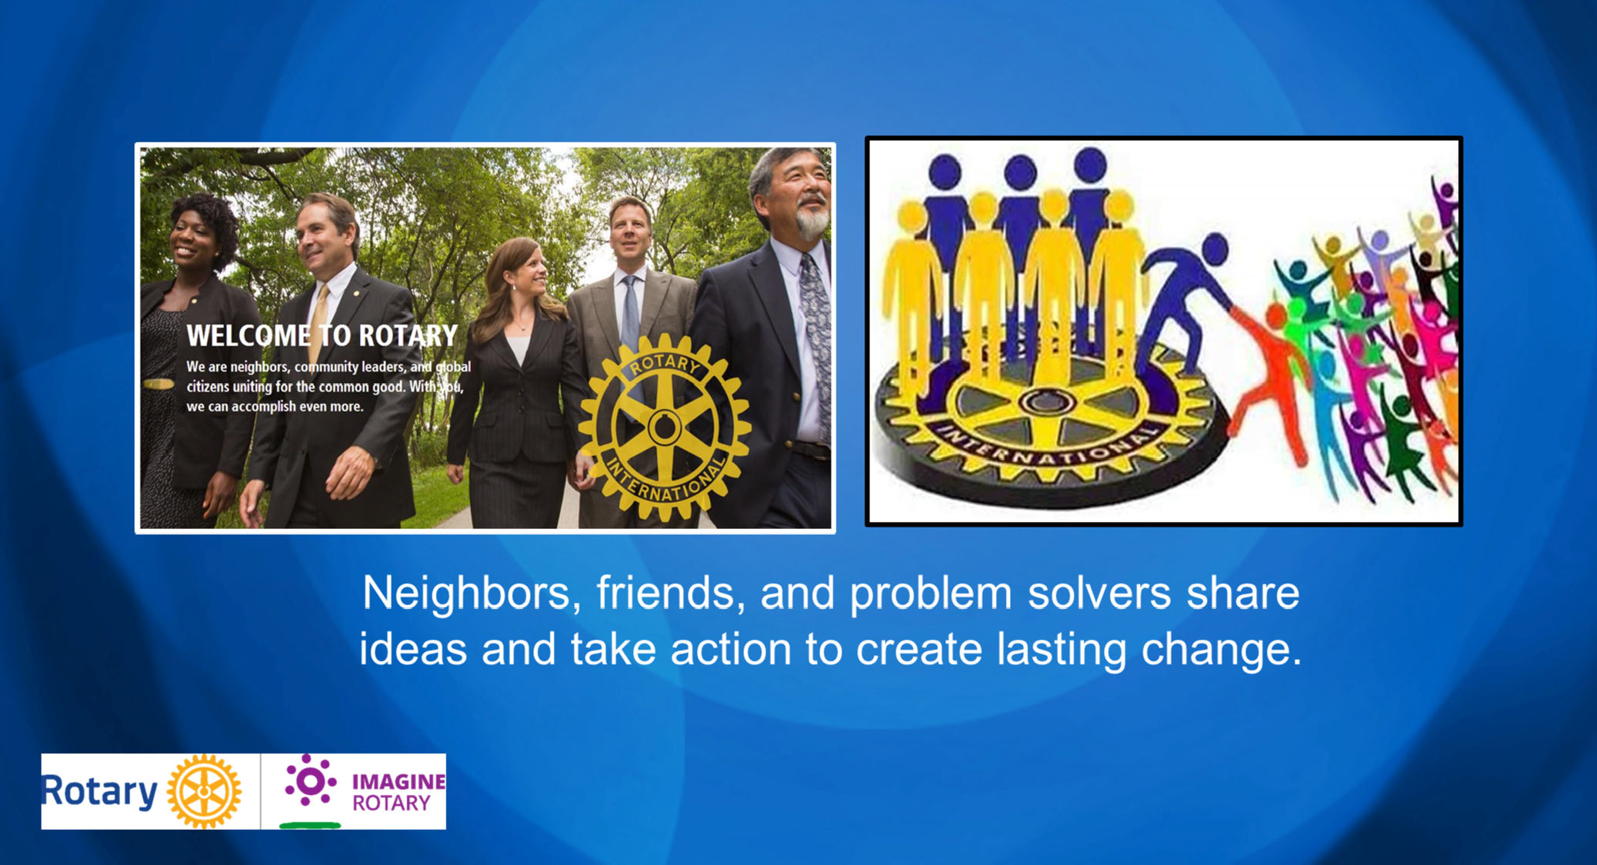

Put simply, Rotary is where neighbors, friends, and problem solvers share ideas and take action to create lasting change. It can be a life‐changing experience because of the extraordinary people you will meet. Rotarians who will be a mentor and role model for you and who will help you build your business network.

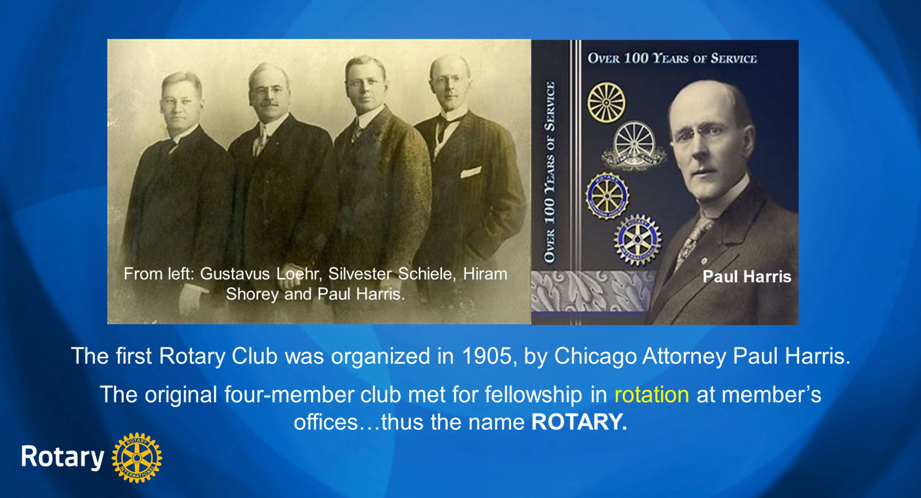

Great history in how Rotary got started. Paul Harris an attorney in Chicago gathered some friends in 1905 for fellowship and it grew from there. Their first reason for being was FELLOWSHIP. Meetings were rotated from office to office and that’s how Rotary got its name.

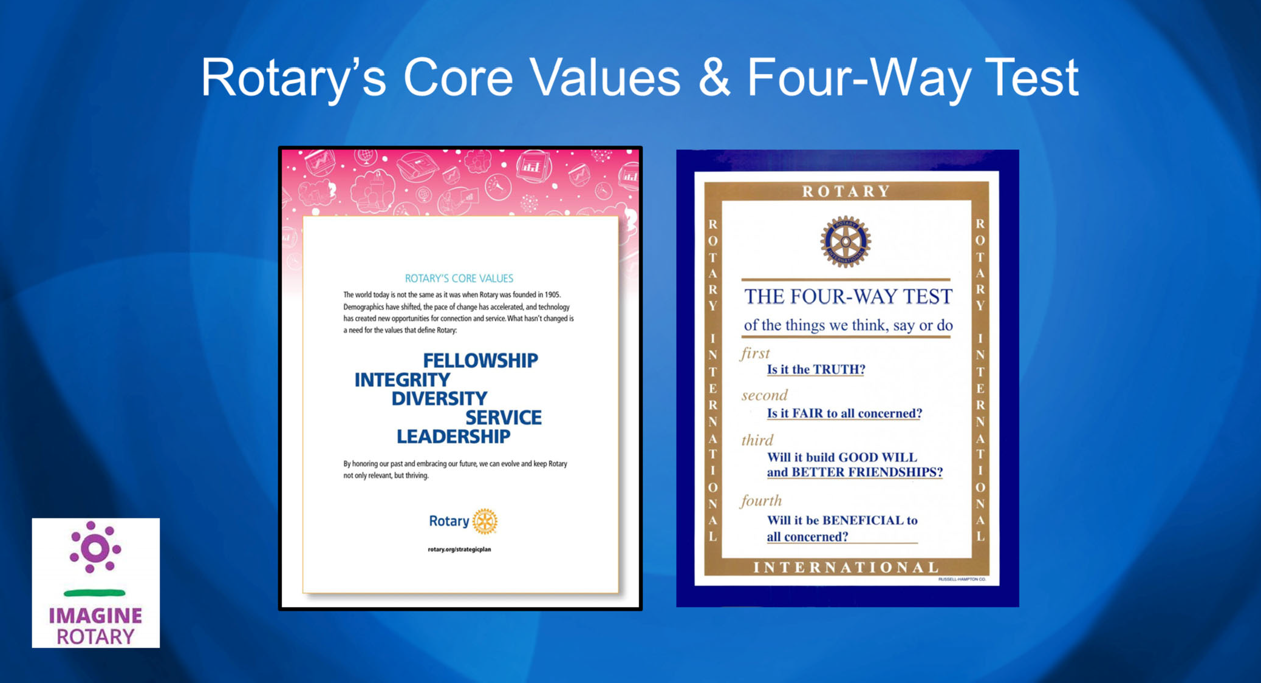

The Four Way Test is used by Rotarians world‐wide as a moral code for personal and business relationships. It can be applied to almost any aspect of life by asking four simple questions…Is it the truth, is it fair to all concerned, will it build good will and better friendships, will it be beneficial to all concerned. Now some Rotarians have added a 5th question, is it fun? Because while we work hard on our projects, we also like to have fun. The four way test goes hand in hand with Rotary’s Core Values. The world today is very different than it was when Rotary was founded in 1905. But what hasn’t changed are our core values of fellowship, integrity, diversity, service and leadership. You can see on the screen I came across a song about the Four Way Test and if we had time we’d have Terry Weaver sing it for us. But since we are pressed for time, we’ll let him off the hook.

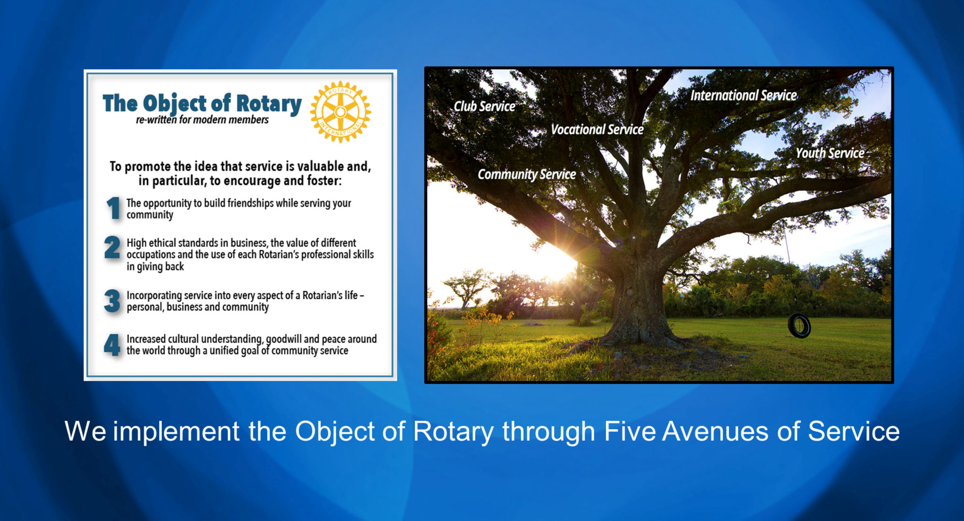

The Object of Rotary is four principles developed over the years to provide Rotarians with a strong, common purpose and direction. They serve as a foundation for our relationships with each other and the action we take in the world. The Object of Rotary comes to life through Five Avenues of Service which are the branches of a deeply rooted membership organization, and they are: Club Service, Vocational Service, Community Service, International Service and Youth Service. This is how we reach out and make a difference in people’s lives around the world and right here at home.

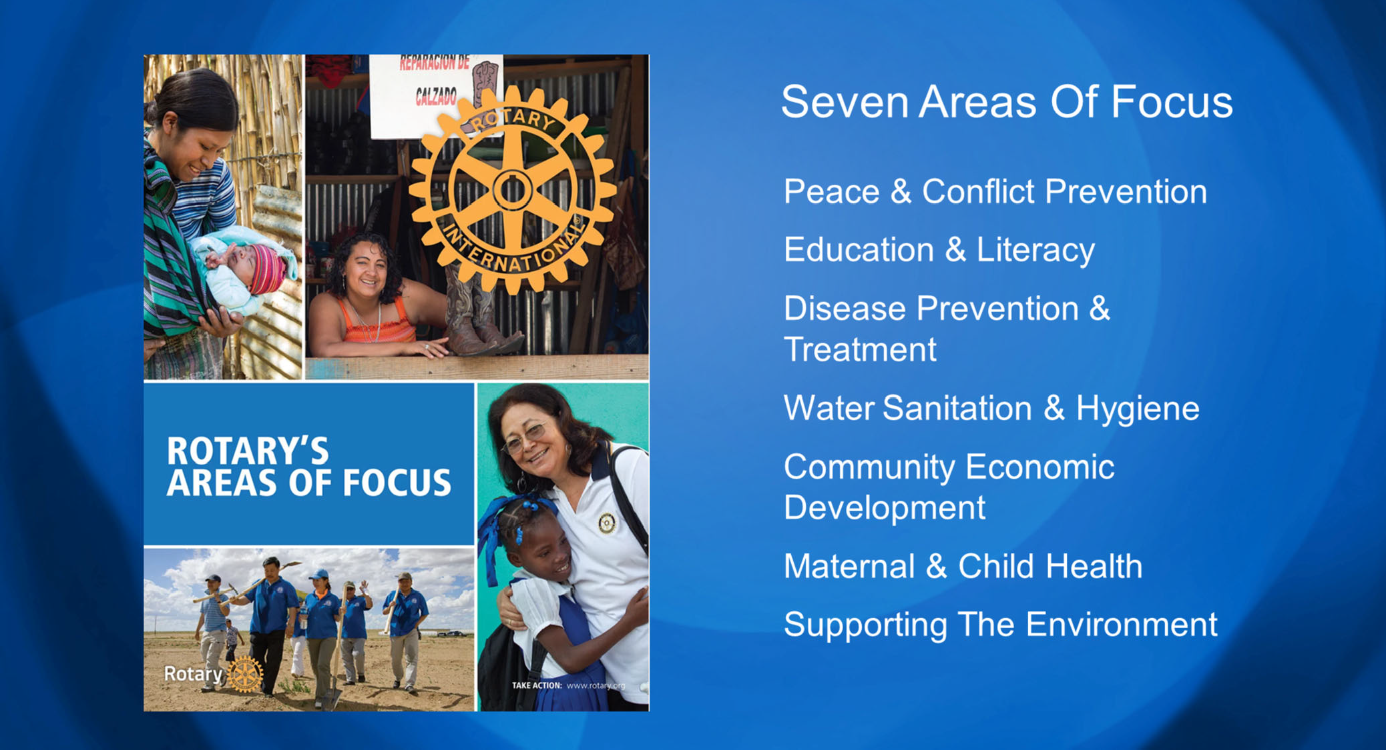

Seven Areas of Focus help us build international relationships, improve lives, create a better world, support peace and end polio forever. All critical humanitarian issues Rotarians have been working on for many years.

Rotary has a non‐profit foundation that promotes world understanding and peace. Since it was founded more than 100 years ago, the Foundation has spent more than $4 billion on life‐changing, sustainable project from preventing disease to providing clean water, supporting education, growing local economies, saving mothers and children and promoting peace.

The Rotary Foundation is best known for its work to end polio in the world. Polio Plus was launched in 1985 and has reached a 99.9% reduction in the number of Polio cases world‐ wide. The Bill & Melinda Gates Foundation joined Rotary in 2017 to commit $450 million to end polio.

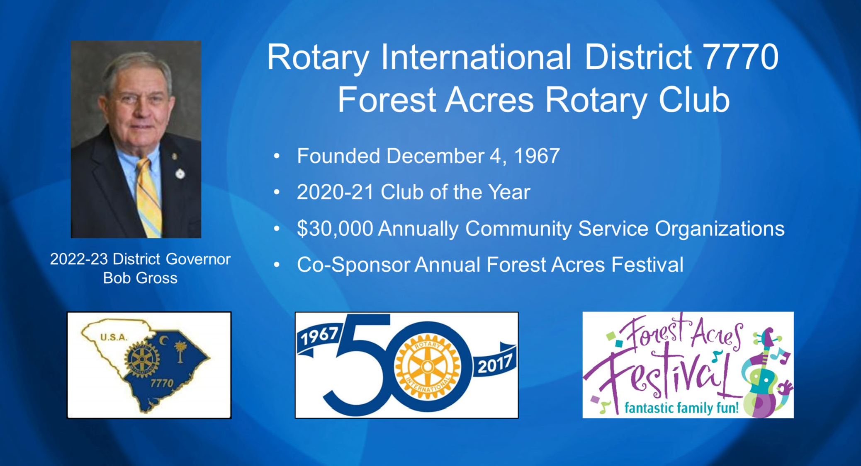

The Rotary Club of Forest Acres is one of 74 clubs in District 7770 that includes 25 counties in eastern South Carolina. Our 2021‐22 District Governor is Paul Walter, a member of the Rotary Club of Hilton Head Island but he originally joined Rotary in Spartanburg in 2001.
Our Forest Acres Club used to be known as a small club with a big heart but so many people have joined the club over recent years, we are now a medium size club with an even bigger heart as we give approximately $30,000 annually to non‐profit community service organizations. We’re known best for the Forest Acres Festival which we have co‐sponsored with the City of Forest Acres for over 20 years.

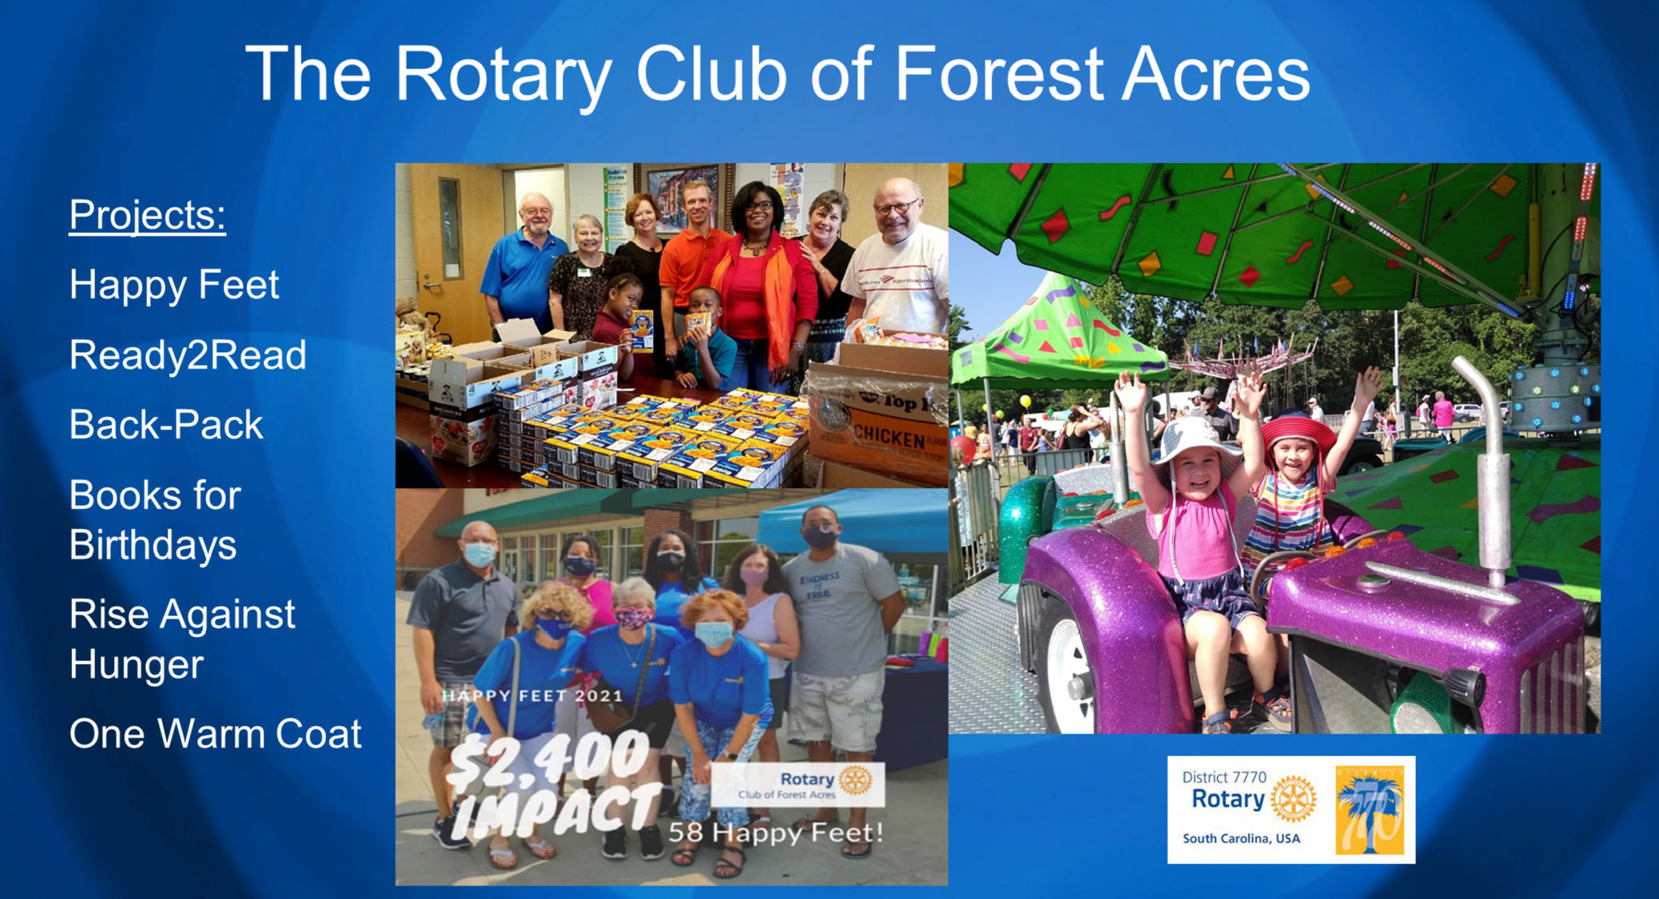

We have several service projects throughout the club year from making sure students have new shoes to start school with to fighting hunger and promoting literacy. We raise money through sponsorships of the Forest Acres Festival.

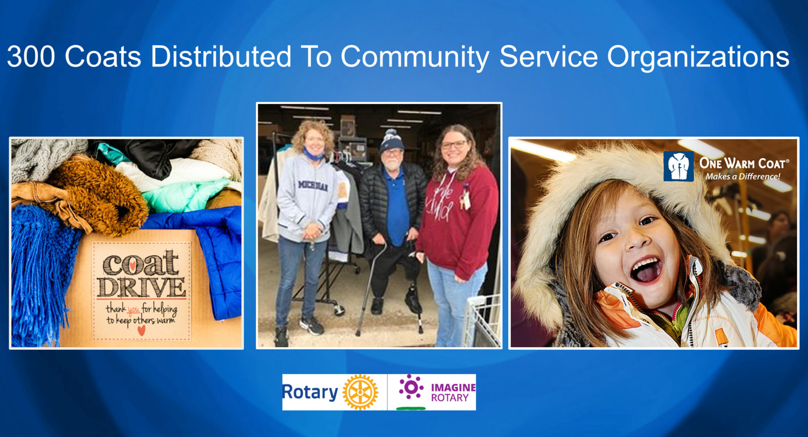

A new project for our club this year was a coat drive held during the month of October. It involved 100% of our club members and we successfully collected 300 hundred coats and distributed them to 10 different community service organizations.

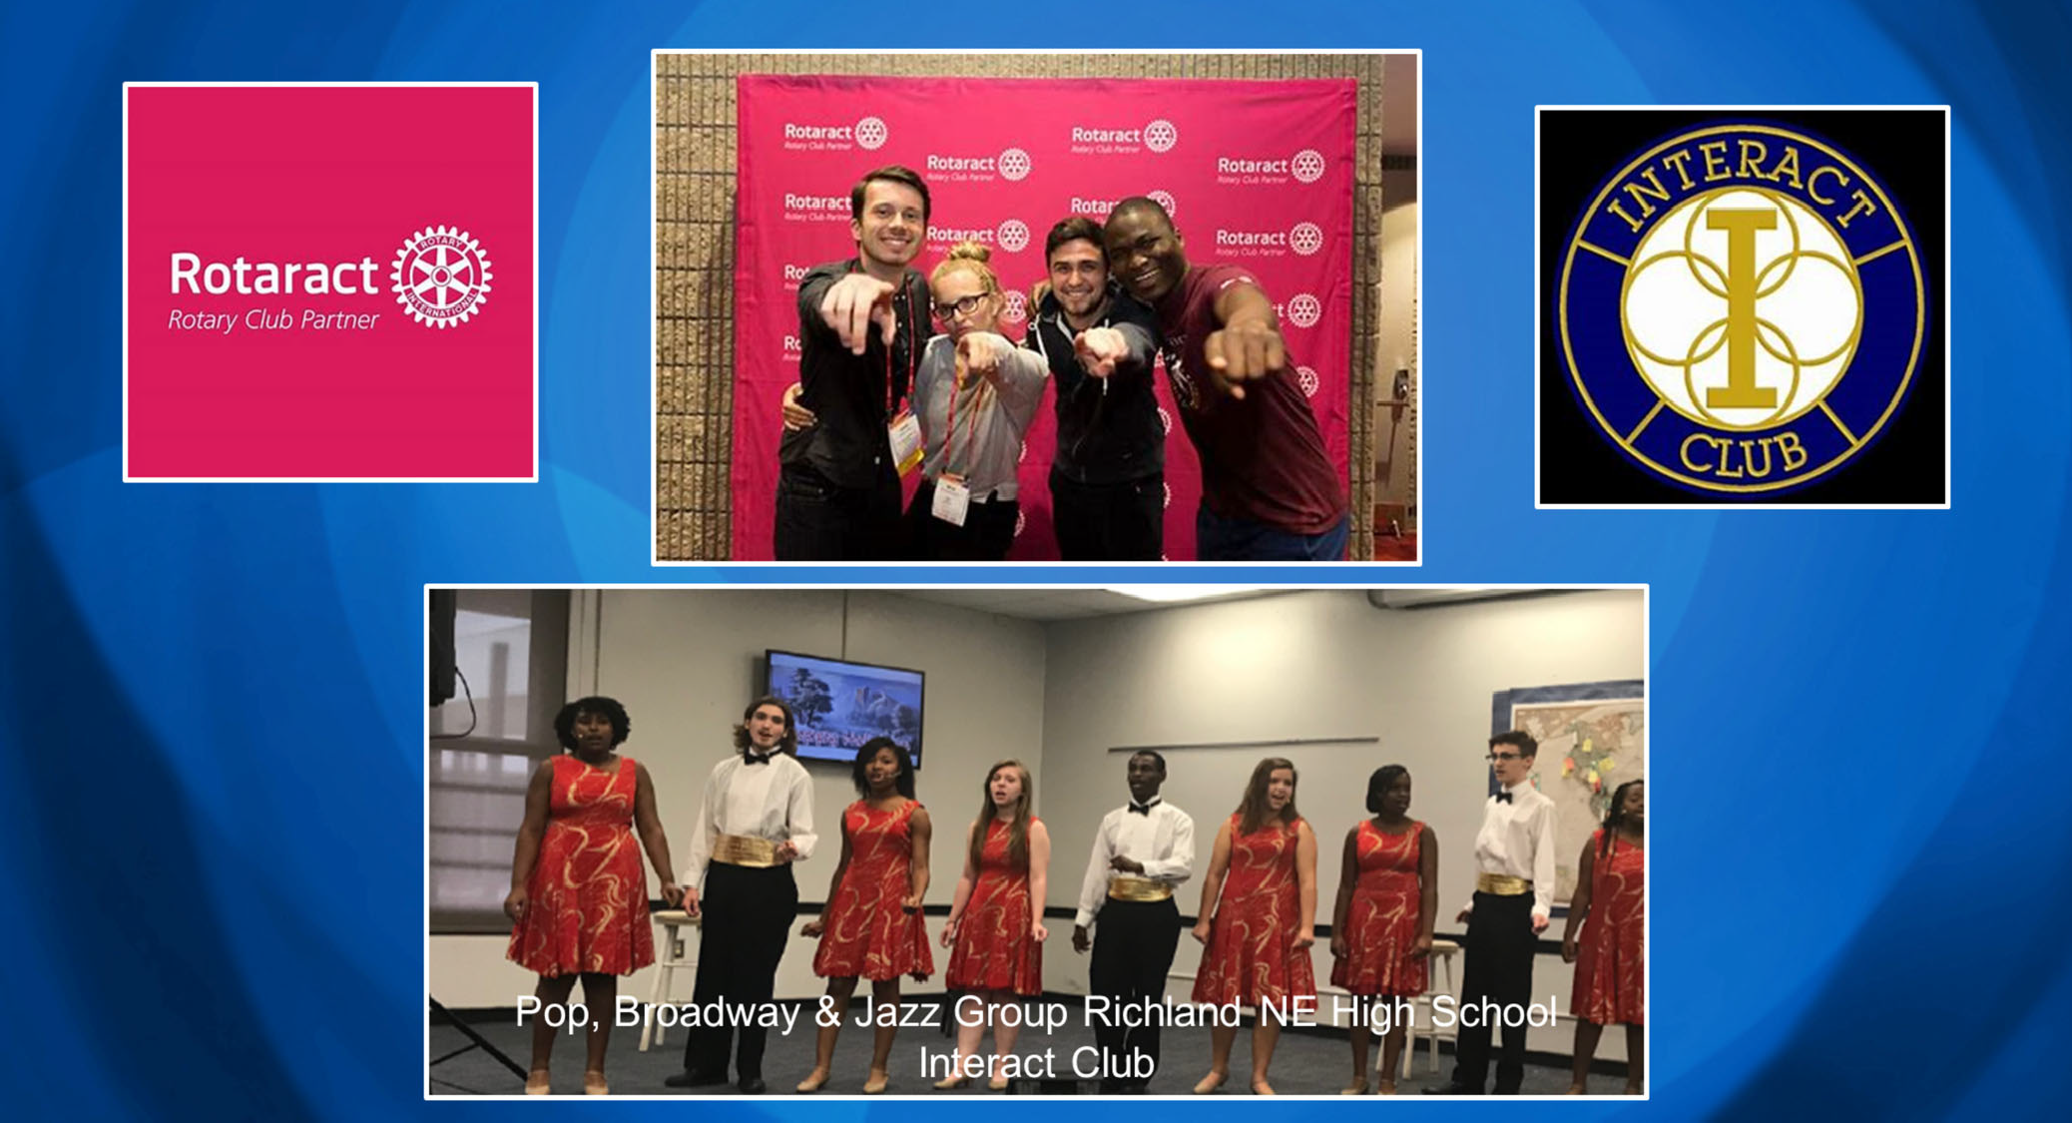

Rotarians believe in developing the next generation of leaders. Our programs help young people build leadership skills, expand education and learn the value of service. They may join Interact Clubs for those age 12‐18 and Rotaract Clubs now available for anyone 18 and older. There are a number of grants and scholarships available from Youth Exchange to Rotary Peace Fellowships.

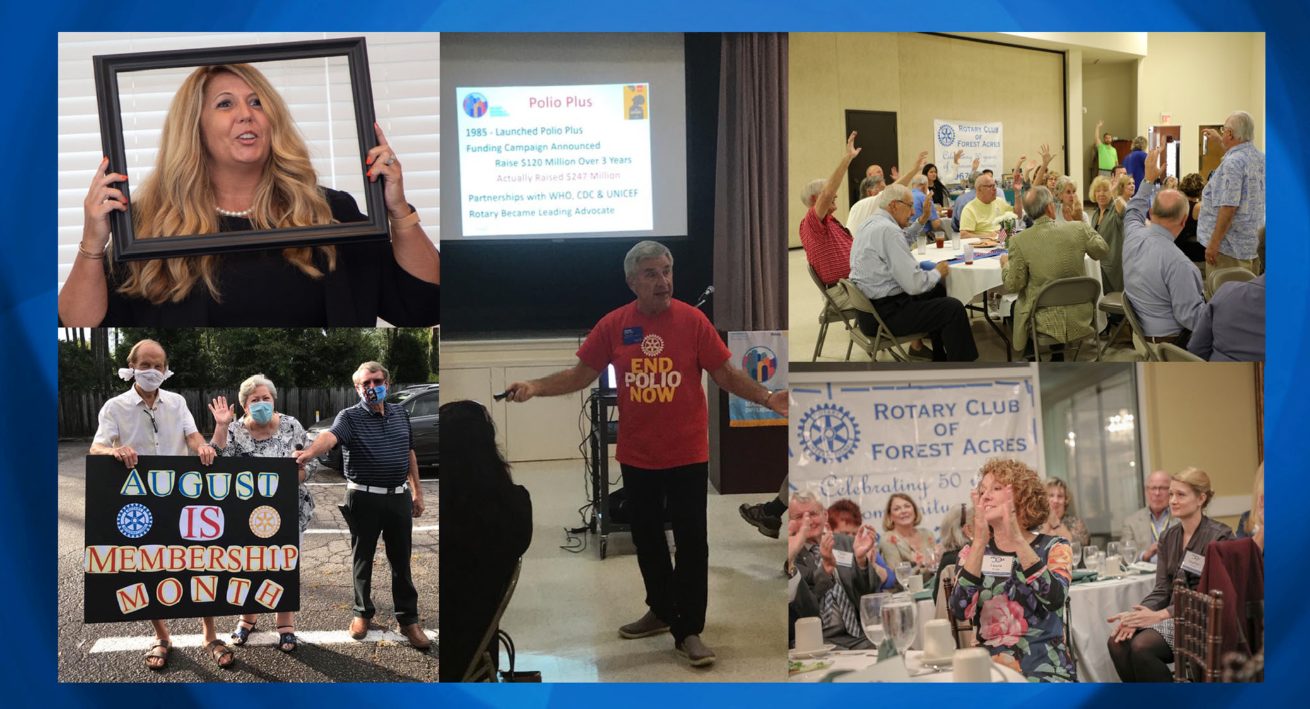

Forest Acres is now recognized as one of the most vibrant clubs in D‐7770. We were recently honored as the 2020‐21 Medium Club of the Year in our District. We have fund club meetings and great speakers, and while we work very hard on our projects and fundraisers…

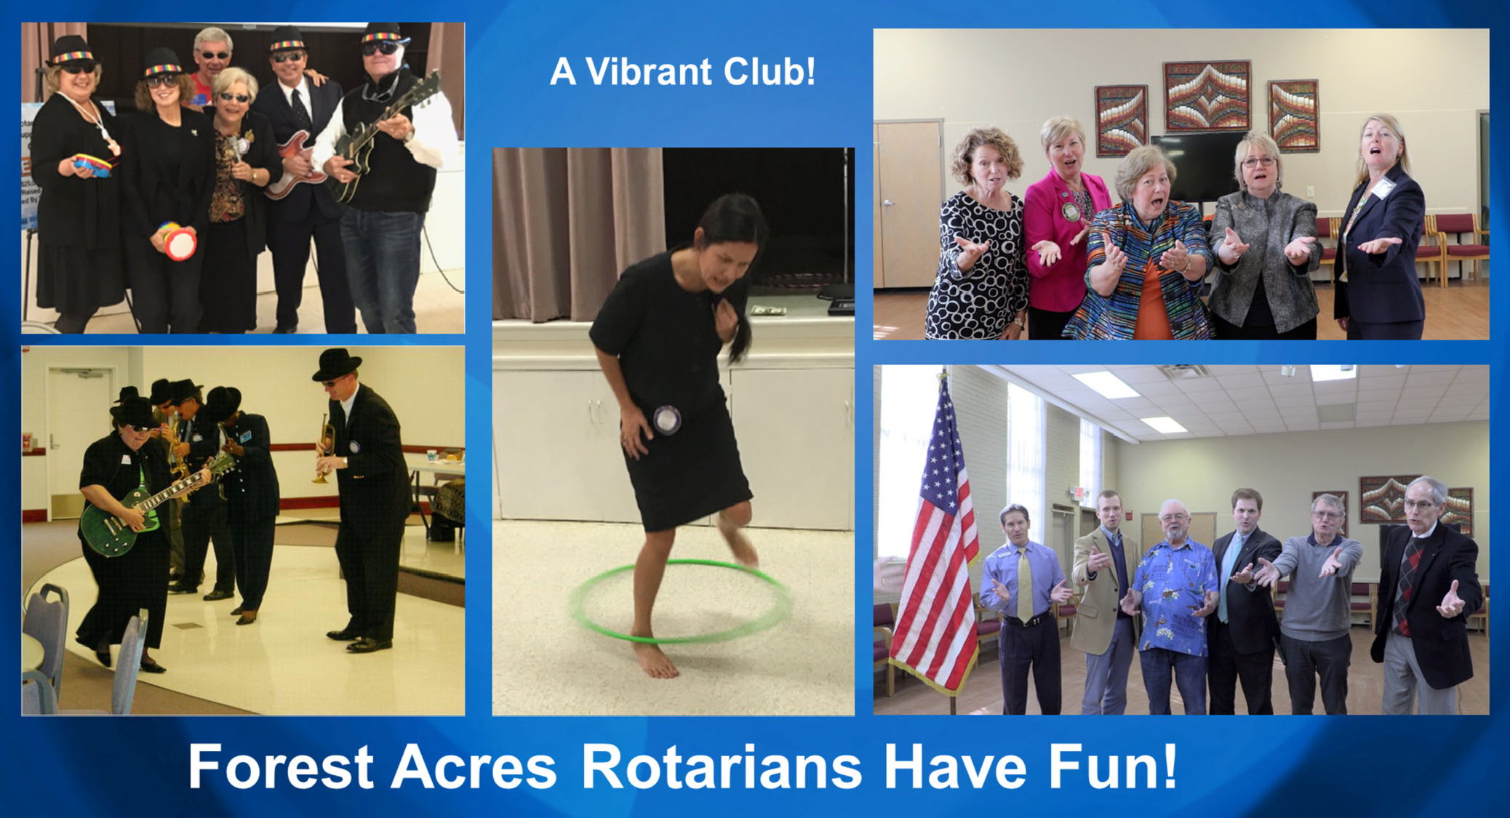

We also know how to have fun! From performing as the Blues Brothers and Sisters to Hoola Hoop contests, and a Chorus Line!

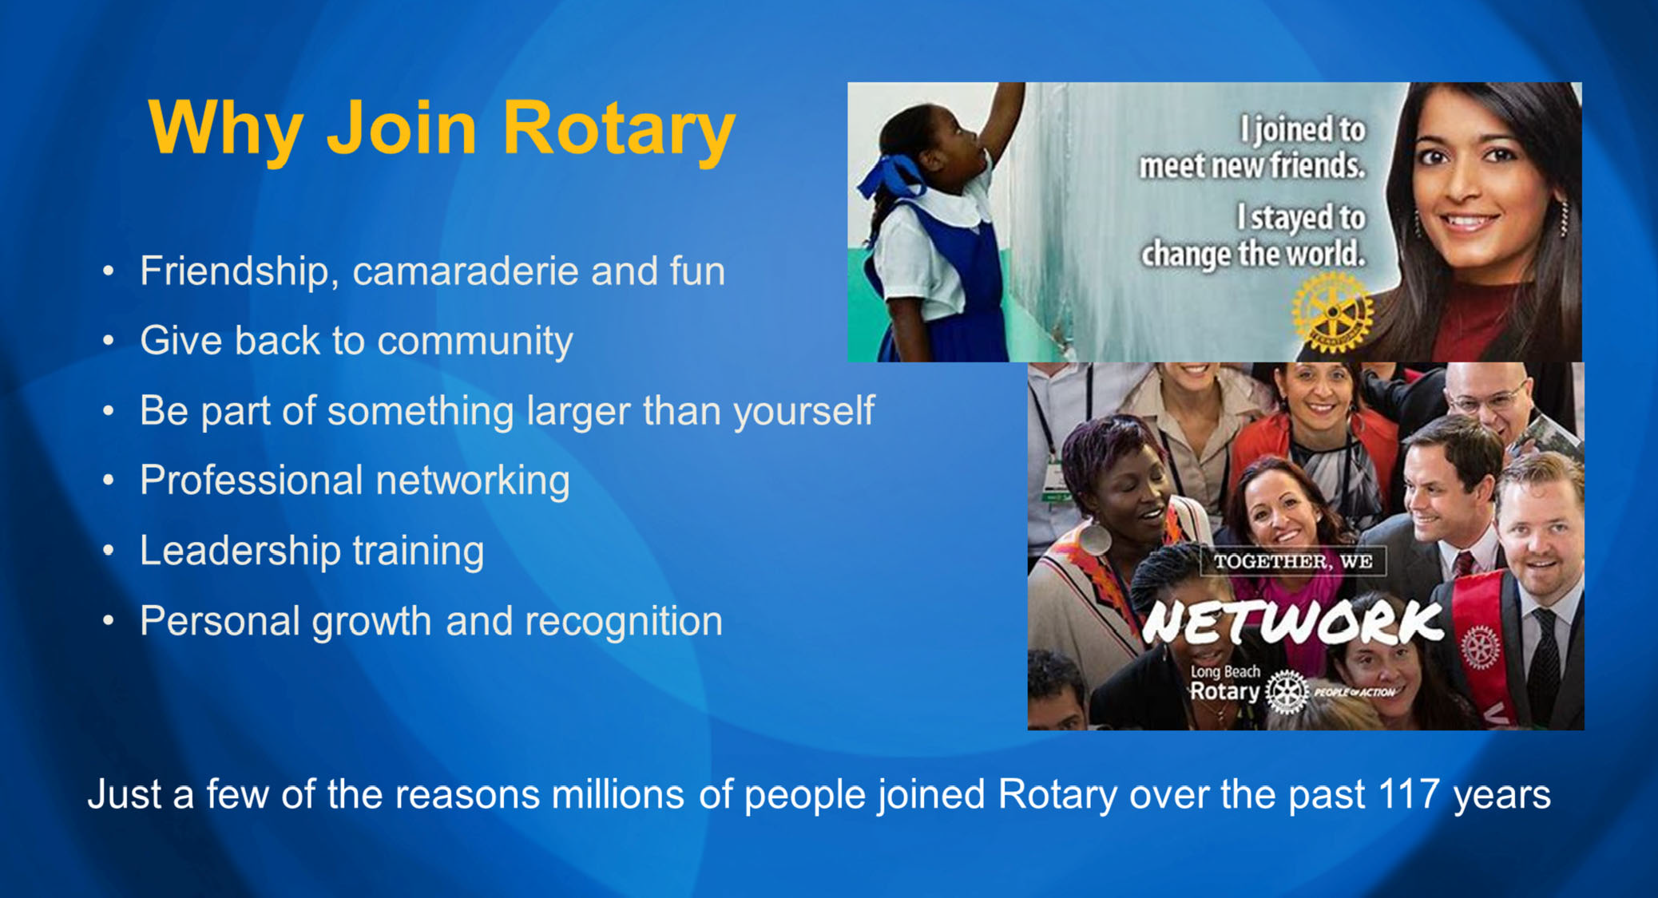

There are many good reasons to join Rotary. Life‐long friends, making the community a better place, being part of something larger than yourself, networking, leadership and personal growth. These are just a few of the reasons why millions of people have joined Rotary over the past 117 year. Yes, Rotary celebrates 117 years of service on Feb 23rd. I’d say we look pretty good to be 117 years old.

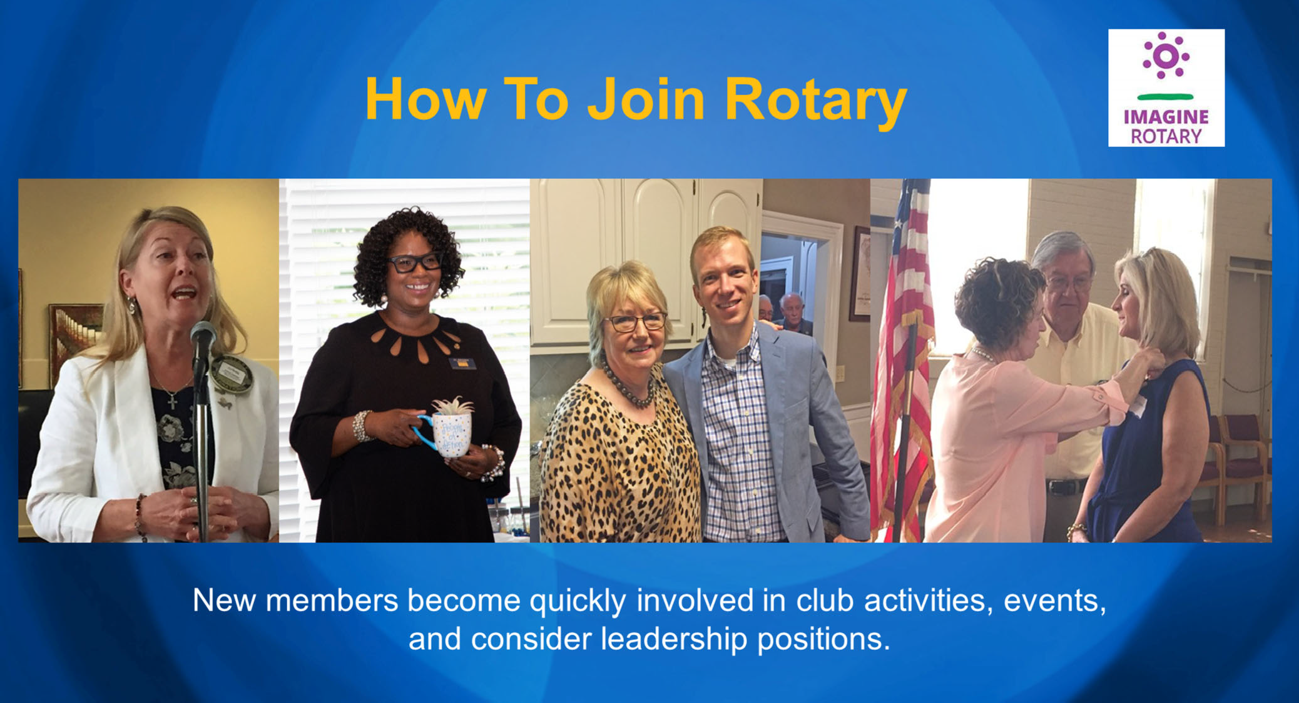

There is a process for joining Forest Acres Rotary. Membership is by invitation from a Rotarian. You submit a completed membership proposal form and when the board of directors approves your membership, you are inducted into the club. You are assigned a new member mentor and attend new member orientation training. But most important of all…you become quickly involved in club activities and events and eventually we encourage all new members to consider a leadership position in the club.

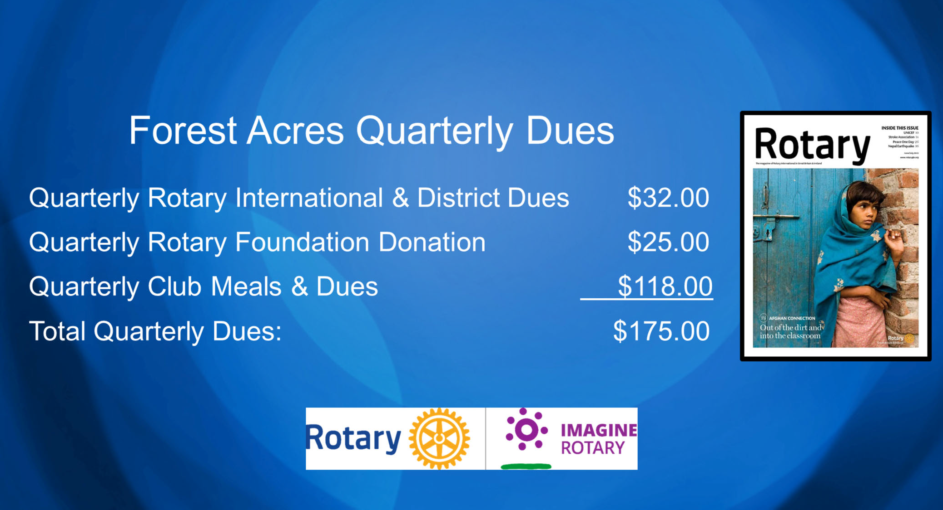

It costs $175 quarterly to be a member of Forest Acres Rotary. That covers RI and District Dues as well as a subscription to the Rotary Magazine. It also includes club dues and meal costs since we are a weekly lunch club.

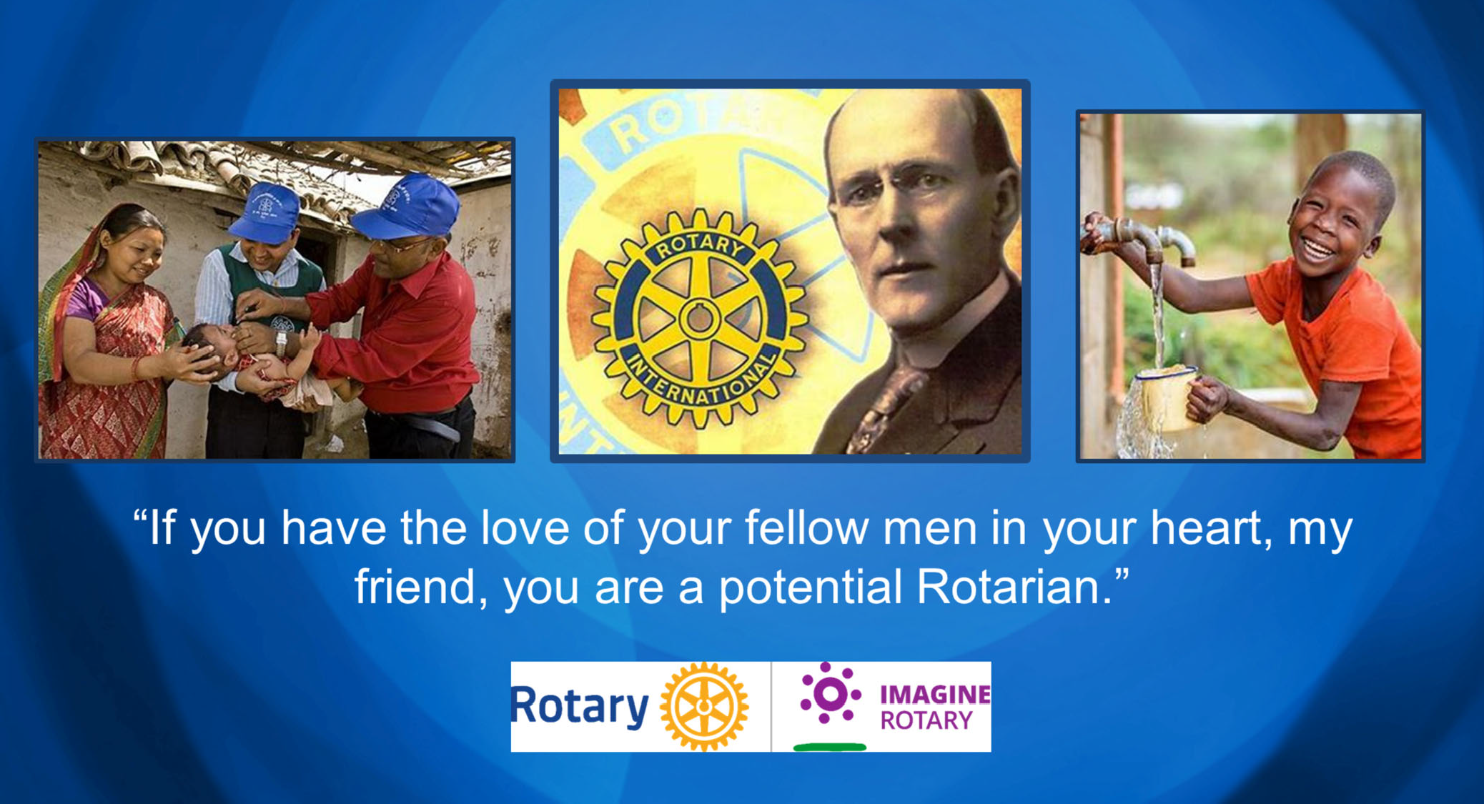

Paul Harris said it best when describing what it takes to be a Rotarian when he said, “if you have the love of your fellow men in your heart, my friend, you are a potential Rotarian.”

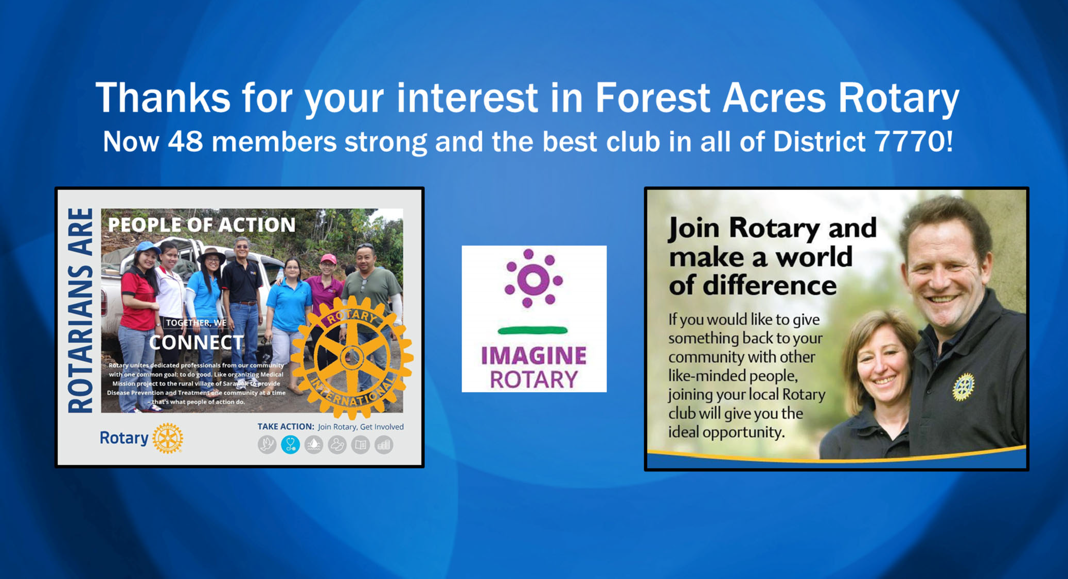

Thanks for your time today and your interest in Forest Acres Rotary. We’ve given you a whole lot of information. Do you have some questions, or was there something that particularly resonated with you or surprised you?

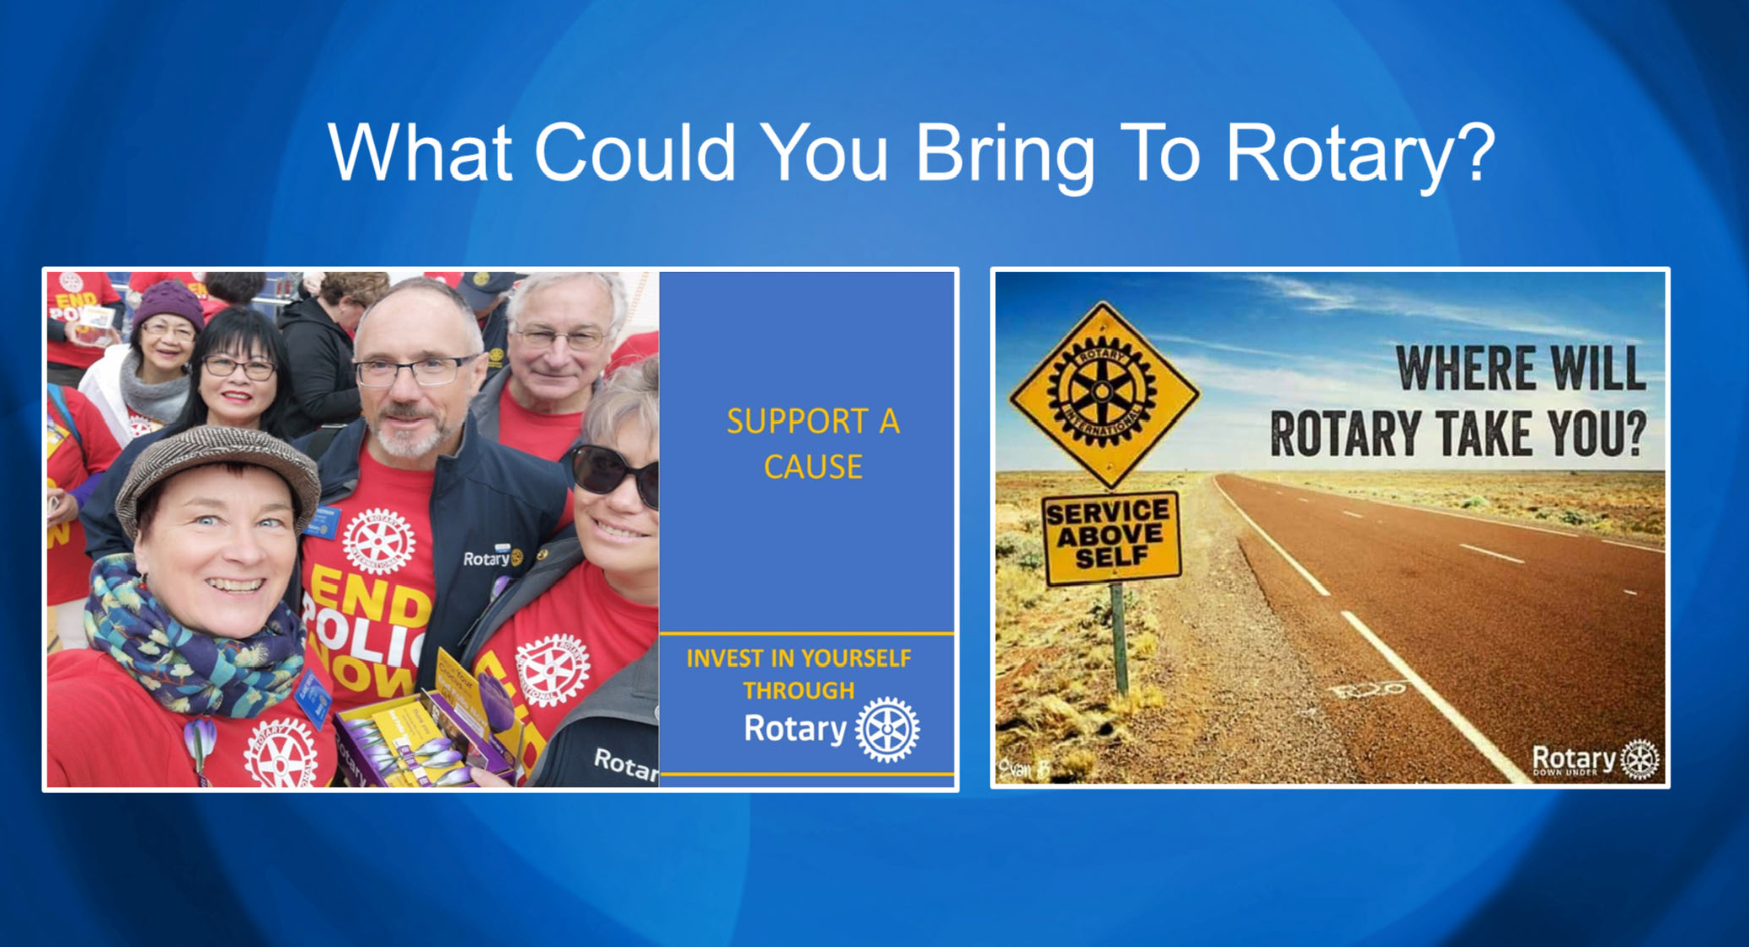

And, finally, what do you think you could bring to Rotary?

And what do you think Rotary could bring to you?

I have 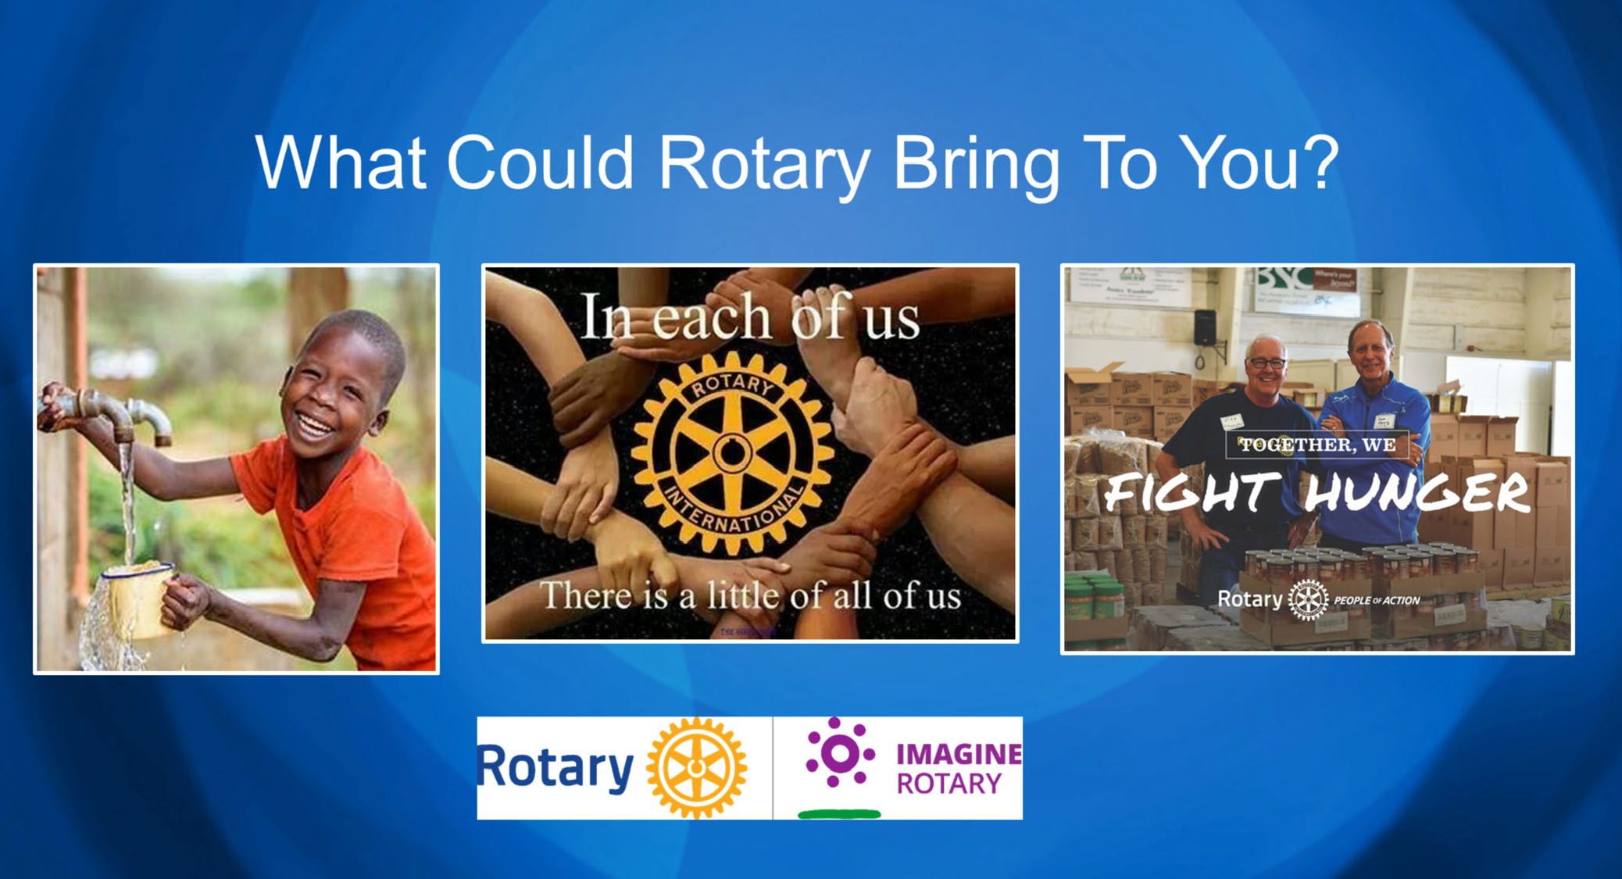a New Member Proposal form for your convenience. There’s no pressure to this – if now is not the time for you to join us, that’s fine. If it IS the right time, just complete the form and return it to your sponsor.

What happens next is our Board will act on your proposal, and if accepted, there’s a short advertising period (7-10 days) and following that we’ll send you an invoice. When you’ve paid your invoice, you become a member and then we’ll plan on a date for your induction and introduction to the club.

